|  |
| --- |
| Auth_user |
| **Auth_user_id int(11)**  **First_name varchar(25)**  **Last_name varchar(25)**  **Email varchar(30)**  **Password varchar(12)**  **Status varchar(25)?** |

|  |
| --- |
| Auth_user_role |
| **Auth_user_id int(11)**  **Auth_role_id int(11)** |

|  |
| --- |
| Auth_role |
| **Auth_role_id int(11)**  **Role_name varchar(25) ?**  **Role_desc varchar(100)?** |

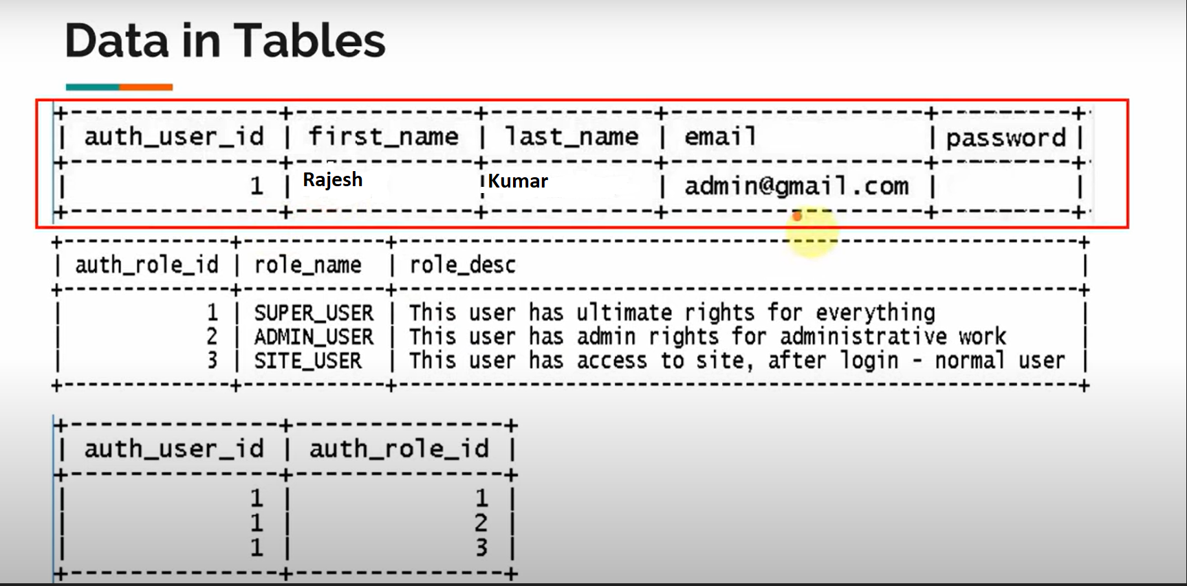

CREATE TABLE auth_role (

auth_role_id int(11) primary key,

role_name varchar(27) DEFAULT NULL,

role_desc varchar(100) DEFAULT NULL

);

INSERT INTO auth_role VALUES (1,'SUPER_USER','This user has ultimate rights for everything');

INSERT INTO auth_role VALUES (2,'ADMIN_USER','This user has admin rights for administrative work');

INSERT INTO auth_role VALUES (3,'SITE_USER','This user has access to site, after login - normal user');

CREATE TABLE auth_user (

auth_user_id int(11) primary key,

first_name varchar(25) NOT NULL,

last_name varchar(25) NOT NULL,

email varchar(30) NOT NULL,

password varchar(12) NOT NULL,

status varchar(12)

);

CREATE TABLE auth_user_role (

auth_user_id int(11) NOT NULL,

auth_role_id int(11) NOT NULL,

PRIMARY KEY (auth_user_id,auth_role_id),

KEY FK_user_role (auth_role_id),

CONSTRAINT FK_auth_user FOREIGN KEY (auth_user_id) REFERENCES auth_user (auth_user_id),

CONSTRAINT FK_auth_user_role FOREIGN KEY (auth_role_id) REFERENCES auth_role (auth_role_id)

);

insert into auth_user (auth_user_id,first_name,last_name,email,password,status) values (1,'Rajesh','kumar','admin@gmail.com','$2a$10$5'VERIFIED');

insert into auth_user_role (auth_user_id, auth_role_id) values ('1','1');

insert into auth_user_role (auth_user_id, auth_role_id) values ('1','2');

insert into auth_user_role (auth_user_id, auth_role_id) values ('1','3');